Step 0) Plug in the device onto a power socket and turn the darn thing on.

Step 1) Have the “ngrok.exe” downloaded and saved at a known location (default: “C:\Users\*User_Name_Here*\Desktop”) on your computer. Run it from the Windows Command Prompt by opening CMD, going at the directory where the .exe is saved and typing “ngrok.exe http 5000”

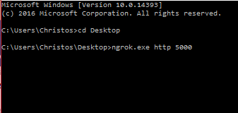

Make note of the second “forwarding” value. It will be different every time. Value will be needed later. Also ascertain that the session status is “online” cause otherwise, you got troubles my friends.

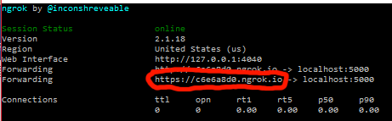

Keep the CMD window running AT ALL TIMES (can be minimised).

Step 2) Log into the “alexa.amazon.com” website to set up the device. This specific one is set up with my account, so for this presentation, I’m inputting the login.

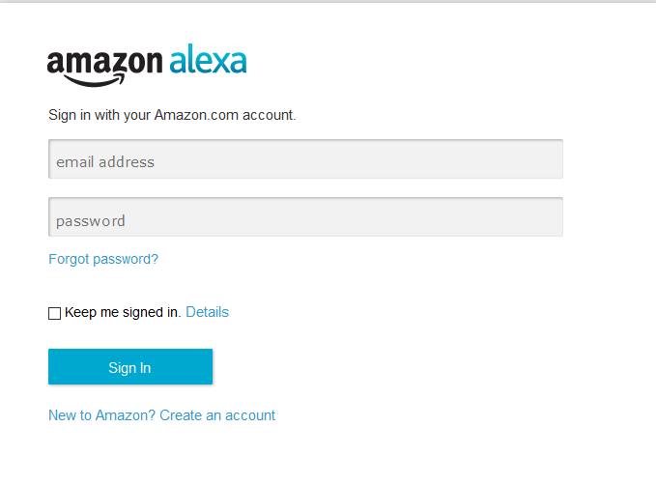

Go to the “Settings” tab, to ascertain that Alexa is connected to the internet (not that it’s going to last for long).



Step 3) Login into “developer.amazon.com” (again, my account, I type) and move to the “Alexa” tab.

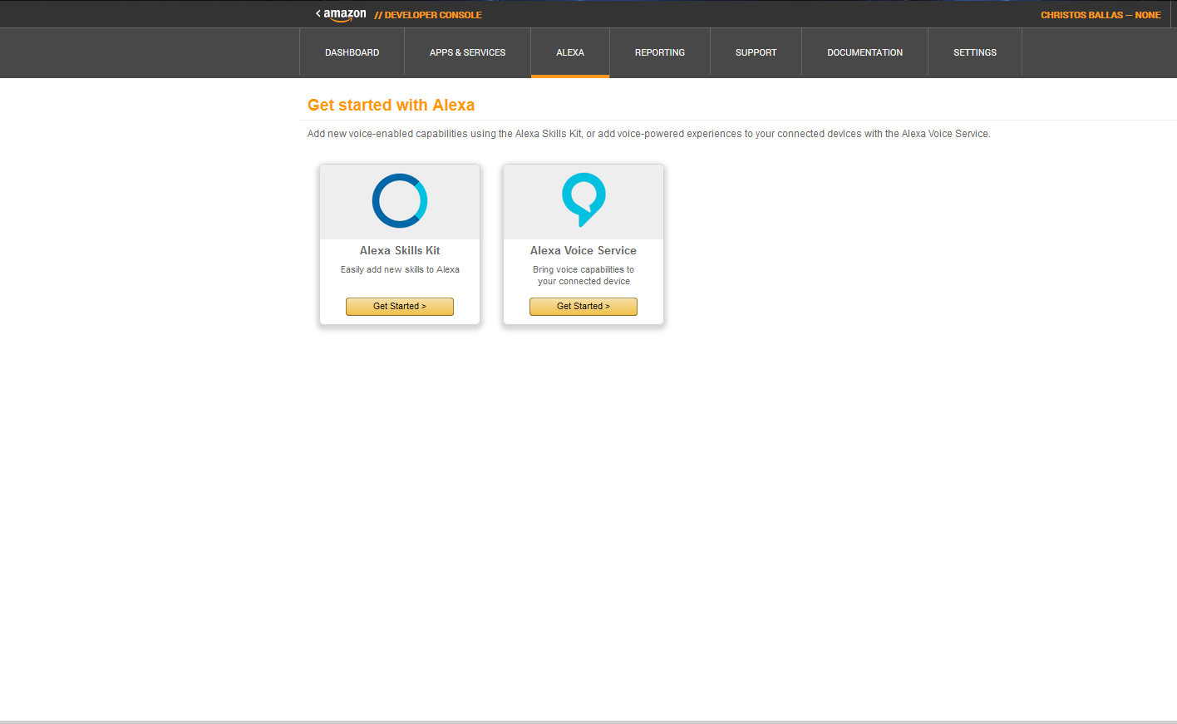

Click on the “Alexa Skill Kit” tab, “Banking – Edit”, “Configuration”, click “HTTPS”, “North America”, and in the box enter the “Forwarding Value” from step 1.

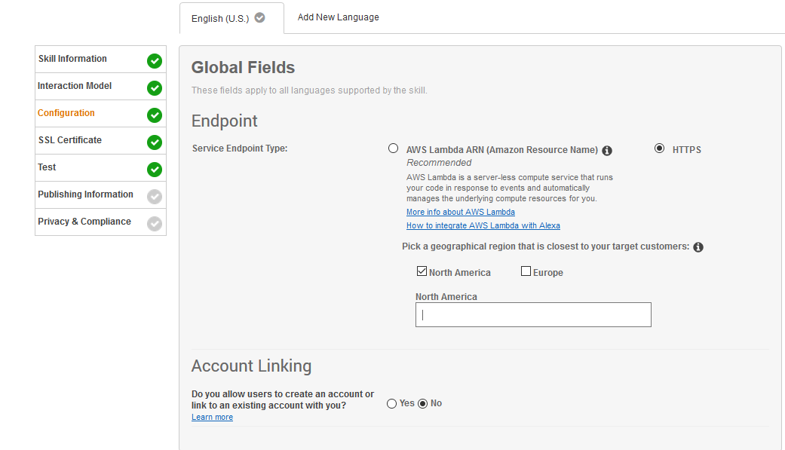

Press “next”, then “next” again. Leave the website open (can be minimised).

Step 4) Open a new CMD window, navigate into the folder where all the .py files are located, and type “python banking.py”.

Should be all set up, but leave the machine a few seconds to boot up and run the files and all.

